**Create a react app for Student Management Portal named scorecalculatorapp and create a function component named “CalculateScore” which will accept Name, School, Total and goal in order to calculate the average score of a student and display the same.**

**Directory:**

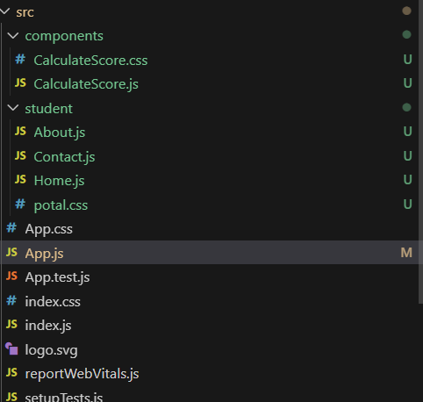

**Code for CalculateScore.js :**

import React from 'react'

import './CalculateScore.css';

const CalculateScore = ({Name,School,Marks,Percentage}) => {

    function Percentage(marks) {

        return ((marks / 100) * 100).toFixed(2);

    }

  return (

    <div>

        <h1 className='red'>Student Details</h1>

        <div className='blue'>Name:{Name}</div>

        <div className='dark-red'>School:{School}</div>

        <div className='purple'>Marks:{Marks}</div>

         <div className='green'>Percentage: {Percentage(Marks)}%</div>

    </div>

  )

}

export default CalculateScore

**Code for CalculateScore.css:**

.red{

    color: red;

    display: flex;

  justify-content: center;

  align-items: center;

   text-align: center;

}

.blue{

    color: blue;

    display: flex;

  justify-content: center;

  align-items: center;

   text-align: center;

}

.dark-red{

    color: darkred;

    display: flex;

  justify-content: center;

  align-items: center;

   text-align: center;

}

.purple{

    color: purple;

    display: flex;

  justify-content: center;

  align-items: center;

   text-align: center;

}

.green{

    color: green;

    display: flex;

  justify-content: center;

  align-items: center;

   text-align: center;

}

**Code for App.js:**

import './App.css';

import CalculateScore from './components/CalculateScore';

function App() {

  return (

<>

<CalculateScore Name={'Shreya Ghosh'} School={'Calcutta Public School'} Marks={85}/>

</>

  );

}

export default App;

Ouput:

